Software Requirements Specification

for

Project Marauders

Version 1.0

Prepared by: Christian Mahima

(B.TECH, V SEM)   
  
Date Created: Sep 26, 2016

Table of Contents

Table of Contents ii

Revision History ii

1. Introduction 1

1.1 Purpose 1

1.2 Document Conventions 1

1.3 Intended Audience and Reading Suggestions 1

1.4 Scope 1

1.5 References 1

2. Overall Description 2

2.1 Product Perspective 2

2.2 Project Functions 3

2.3 User Classes and Characteristics 3

2.4 Operating Environment 3

2.5 Design and Implementation Constraints 3

2.6 User Documentation 4

2.7 Assumptions and Dependencies 4

3. External Interface Requirements 4

3.1 User Interfaces 4

3.2 Hardware Interfaces 4

3.3 Software Interfaces 4

3.4 Communications Interfaces 5

3.5 System Features 5

4. Other Nonfunctional Requirements 9

4.1 Performance Requirements 9

4.2 Safety& Security Requirements 9

4.3 Software Quality Attributes 9

4.4 Business Rules 9

5. Other Requirements 9

Appendix A: Glossary 9

Appendix B: To Be Determined (TBD) List 9

Revision History

|  |  |  |  |
| --- | --- | --- | --- |
| **Name** | **Date** | **Reason For Changes** | **Version** |
|  |  |  |  |
|  |  |  |  |

# Introduction

## Purpose

Project Employment Engagement System is an web application for Popcorn Apps. It is basically a mode of communication between employees and managers of the organization. This website will engage all workers inside the company making it easy for them to work. Project includes features like leave application, salary status, project and event updates, etc.

## Document Conventions

* SRS: Software Requirements Specification
* PhoneGap: Mobile Application development framework
* IOS: (iPhone Operating System), an operating system used for mobile devices manufactured by Apple Inc.
* AWS: Amazon Web Services
* LAMP stack: Software stack consists of Linux, Apache, MySQL and PHP

## Intended Audience and Reading Suggestions

Our intented audience is anyone who are related to the project contribution such as, such as developers, project managers, marketing staff, users, testers, and documentation writers.

## Scope

Relevant objective for Employment Engagement System is that all employees interact with one another as well as their superiors. Major benefit here is interaction. There always persists an interaction gap between employees which leads to degraded quality of the product, conflicts and confusion. To reduce this, employment engagement is the best possible way out. All 100+ employees of the company ‘Popcorn Apps’ will be using this web application.

## References

PhoneGap: A mobile application development framework by Adobe. <http://phonegap.com/>

# Overall Description

## Product Perspective

This Employee Engagement Application is a self-contained application. It maintains its own database and does not depend on any external systems to GET or POST data. Below diagram explains in detail.

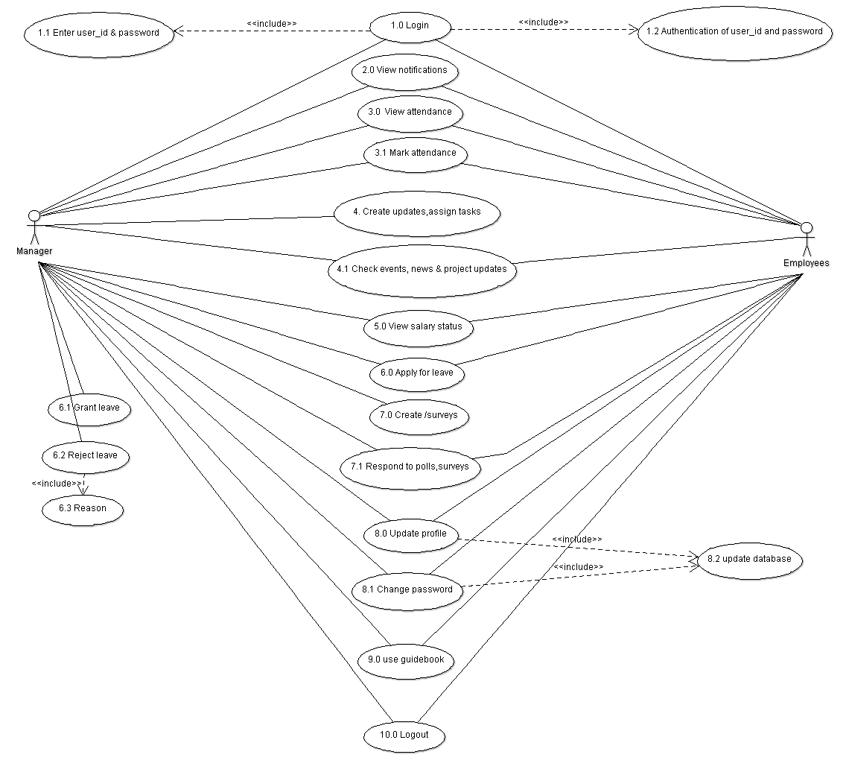



## Project Functions

The following will be the product function for now, later need be obviously more functions can be added:

1. **Manager employee login** : There will be unique username and password given to each and every user. Here user is an employee of the company. After login, user will be directed to the home page where there will be notifications, user’s work related updates, etc.
2. **Attendance** : User can access or update his/her attendance using login details with specified time under the company’s network only. Attendance section is not available with other networks.
3. **Salary Status** : User will be able to access anytime on any network the salary status. As in what is the salary he will be receiving this month subtracting individual holidays/leave taken and adding taxes applied to the employee. If he/she has any loan over them, the due amount will be displayed.
4. **Leave Application** : If a User applies for a leave, notification will be received by the assigned manager. Then the manager may approve or disapprove according to the company norms. The user will be able to view all status regarding the leave as in what leaves he/she has taken with a particular duration. Also the type of leave the user has taken like casual leave, restricted leave, etc
5. **Feedback** : Any user including all employees of the company can suggest his/her views over the project or any event of the company. This way the company could get the inputs of the employees which helps the company to forward in a compatible direction for everyone.
6. **Event or Project Updates** : Updates will be in a form of news which will include all upcoming events and as well as all project updates concerned with a particular employee. Also news such as arrival of a new employee in the company.

## User Classes and Characteristics

The expectation of people using this software is expected to be with the organization having employees ID/number.This application would be highly useful to large organizations as it wills become easy to manage and communicate with its employees.

## Operating Environment

This web application operates on a LAMP stack Standard Operating Environment in AWS medium instance. Entire application is hosted on this single instance. No other dependencies are there.

## Design and Implementation Constraints

NONE

## User Documentation

*The software is self-sufficient and does not need any tutorials or any external help. But for the convenience of the user, an additional document containing the user flow will be attached. It will be included in the help tab of the application.*

## Assumptions and Dependencies

**Assumptions:**

* Data transfer, synchronization/migration is out of scope of this project.
* Before starting the project, PopcornApps will give device matrix that the app should support
* PopcornApps to provide sample employee data to test the application
* PopcornApps to provide timely feedback

**Dependencies:**  
  
None

# External Interface Requirements

## User Interfaces

*This is maintained as user friendly as possible. However, a lot of priority has been given to avoid third party and not genuine plugins to avoid any issues which could cause any unauthorized access or hampering of data. The work flow of the software is also in sync with the functionalities listed. However, for any user to access the information, a login page will be in its rightful place. The software is so designed to inform the user on his/her mobile phone via a message if the account of the specific user has been tried to access with wrong pass codes 3 times in a row.*

## Hardware Interfaces

No external or extra hardware components are required to facilitate the functionality of this application.

## Software Interfaces

*The only possible way to login to the application will be the username and password, username will be unique for every employee. All the functions mentioned inside the software will be accessed by authorized users only. It will also be a platform independent system allowing the users with the freedom to use any machine they like without constraining them to use particular machines with exception of marking attendance where the user has to login to the application using the organization's network only to prevent discrepancies*.

## Communications Interfaces

Communication standards that are going to be used are FTP&HTTP. Nodata/application encryption mechanism is required.

## System Features

USER LOGIN

|  |  |  |
| --- | --- | --- |
| **REQUIREMENTIDENTIFIER** | **NAME** | **DESCRIPTION** |
| *UL_1* | *USER LOGIN-1* | *The user-id and password entered by the user will be authenticated by matching it with the database.* |
| *UL_2* | *USER LOGIN-2* | *If the entered user-id or password do not match then user will be notified to re-enter the former.* |
| *UL_3* | *USER LOGIN-3* | *If the user forgets his/her password, he/she will be required to reset it by entering his/her email-id after which he/she will receive a password reset notification on the registered email-id.* |
| *UL_4* | *USER LOGIN-4* | *If the user-id and password is successfully authenticated, the user is directed to his/her dashboard.* |

ATTENDANCE

|  |  |  |
| --- | --- | --- |
| **REQUIREMENTIDENTIFIER** | **NAME** | **DESCRIPTION** |
| *AD_1* | *ATTENDANCE-1* | *On clicking the attendance button the user will be given an option to either check his attendance record or to mark his/her daily attendance.* |
| *AD_2* | *ATTENDANCE-2* | *If the user selects check attendance option, he/she will be shown the attendance record.* |
| *AD_3* | *ATTENDANCE-3* | *If the user wants to mark his/her attendance it is mandatory to login using the organization’s network. If this requirement is met the user will able to mark his/her attendance.* |
| *AD_4* | *ATTENDANCE-4* | *If the user has not logged in using the organization’s network and tries to mark his/her attendance, he/she will be shown an error display message.* |

LEAVE APPLICATION

|  |  |  |
| --- | --- | --- |
| **REQUIREMENT IDENTIFIER** | **NAME** | **DESCRIPTION** |
| *LA1* | *LEAVE APPLICATION-1* | *Apply for leave.* |
| *LA2* | *LEAVE APPLICATION-2* | *Send notification that an employee has applied for leave to the concerned manager.* |
| *LA3* | *LEAVE APPLICATION-3* | *If leave is granted notification is sent to the concerned employee.* |
| *LA4* | *LEAVE APPLICATION-4* | *The manager may choose to reject the leave application with a valid reason and notification will be sent to the employee* |

SALARY STATUS

|  |  |  |
| --- | --- | --- |
| **REQUIREMENTIDENTIFIER** | **NAME** | **DESCRIPTION** |
| *SS_1* | *SALARY STATUS-1* | *If the user clicks on the salary status button, he/she will be shown his/her last months received salary. The user will also be able to see any tax/salary cuts as well as any bonuses received. User will also able to see previous salary records.* |

NOTIFICATIONS

|  |  |  |
| --- | --- | --- |
| **REQUIREMENTIDENTIFIER** | **NAME** | **DESCRIPTION** |
| *N_1* | *NOTIFICATION-1* | *The user will see a notification box in the dashboard in which he/she will be able to see notifications. On clicking any of the notifications the user will be directed to the notification page where he/she will be able to see the complete message.* |
| *N_2* | *NOTIFICATION-2* | *The user will also be able to go to notifications page using a notification button.* |

NEWS_SURVEY

|  |  |  |
| --- | --- | --- |
| **REQUIREMENT IDENTIFIER** | **NAME** | **DESCRIPTION** |
| *NS1* | *NEWS_SURVEY-1* | *View updates, news and events like promotions, holidays, etc.* |
| *NS2* | *NEWS_SURVEY-2* | *A user can view and may respond to the polls and survey.* |
| *NS3* | *NEWS_SURVEY-3* | *Any user who is a manager can create polls and surveys* |

ASSIGNED TASKS

|  |  |  |
| --- | --- | --- |
| **REQUIREMENT IDENTIFIER** | **NAME** | **DESCRIPTION** |
| *AT* | *ASSIGN_TASK* | *A user who is a manager can assign tasks to certain employees upon which those employees will receive notifications.* |

SETTINGS

|  |  |  |
| --- | --- | --- |
| **REQUIREMENT IDENTIFIER** | **NAME** | **DESCRIPTION** |
| *S1* | *SETTINGS-1* | *An user can change his/her password or which the suitable notification will be sent* |
| *S2* | *SETTINGS-2* | *An user can update his/her profile for which the suitable notification will be sent* |
| *S3* | *SETTINGS-3* | *Make necessary changes in the corresponding database* |

HELP

|  |  |  |
| --- | --- | --- |
| **REQUIREMENT IDENTIFIER** | **NAME** | **DESCRIPTION** |
| *H* | *HELP* | *Contains an user guide* |

LOGOUT

|  |  |  |
| --- | --- | --- |
| **REQUIREMENT IDENTIFIER** | **NAME** | **DESCRIPTION** |
| *LO* | *LOGOUT* | *Let’s the user logout of the application and displays a thank you message along with a link for the login page* |

# Other Nonfunctional Requirements

## Performance Requirements

*There are no specific and high requirements as such, any browser, with a genuine operating system will be able to support this software.*

## Safety& Security Requirements

PopcornApps company safety and security policies are followed. No additional requirements.

## Software Quality Attributes

*The quality of software is high. It has been put through a rigorous and a large variety of tests. There are no doubts on its features such as: adaptability, availability, correctness, flexibility, interoperability, maintainability, portability, reliability, reusability, robustness, testability, and usability. Write these to be specific, quantitative, and verifiable when possible. The user will not find any issues with the system.*

## Business Rules

This software is operated by the employees of the organization governed by the defined policies and security measures. Every individual who operates/uses this software must adhere to the company policies and security measures.

# Other Requirements

*None as such. However, it might be a good idea/ better practice to keep the browsers upgraded and updated, with use of genuine copy of the operating system and keeping a fast internet link.*

Appendix A: Glossary

***User(s)****: An employee of the organization*

***Organization****: PopcornApps*

Appendix B: To Be Determined (TBD) List

None for now. But as the document gets updated, this section will get updated if any TBD items are found.